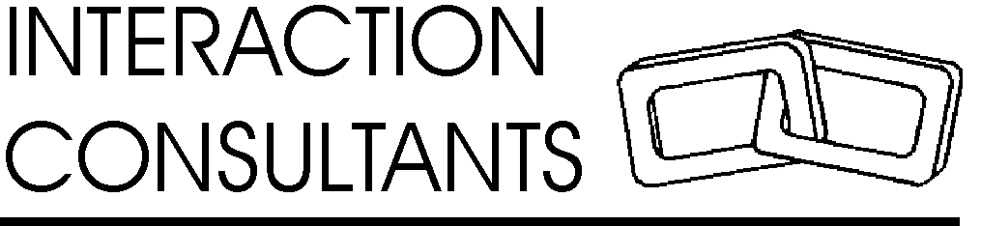

Am I Fat?

Most husbands would agree that to hear that question from their wife is akin to being asked to boil oneself in oil. However, what about when a child asks or needs to be informed?

As recently reported (July 2006), the American Medical Association and the Center for Disease Control have been discussing just how to inform a child and parents when a child’s weight is greater than appropriate for age, height and gender. At issue is upsetting the child or family if they are told directly that the child is obese. Hence they are considering adopting the terms, “at risk of overweight” when body mass index is in the 85th - 94th percentile for their sex and age, and “overweight” when body mass index exceeds the 94th percentile. Of concern to their position, is that by being indirect about the issue, the child and parents may not take the situation as seriously as necessary and the child’s health may thus be compromised.

The above discussion occurs in a context where obesity rates in America have more than doubled in the past 30 years and today’s children and youth may not live as long as their parents for no other reason but for their obesity. Obesity leads to coronary heart disease, stroke and diabetes.

Obesity stands in stark contrast to eating disorders such as anorexia and bulimia and it may be that in view of these disorders, parents and professionals alike are actually afraid of harping on weighty kids, fearing the pendulum may swing in those directions. Further, with so much talk about self-esteem, there is also concern that direct discussion on matters of weight might cause children to feel poorly about themselves.

It seems the pendulum has so swung in favour of concern for psychological processes that physical health is now compromised. The challenge is to bring both into balance where neither physical nor psychological health be put at risk.

With regard to obesity, it is perhaps best then if taken out of the realm of psychology and treated as the medical issue it is. As we similarly are forthright about other medical conditions our children face, so too should we be forthright about obesity. Children need to learn about appropriate nutrition, diet, health, exercise and self-care. If their weight is greater than appropriate, they should receive reasonable feedback and direction to remedy the condition, just as they would any other medical concern.

In the long run, self-esteem is a function of being valued. Concern for a child’s medical well-being is an indicator to the child of being valued despite any upset that may be felt in the moment. Further, concern for the longevity and health of a child is about as caring a gesture a parent can make. Lastly, it is actually more difficult to feel good about oneself as a child if weight causes the child to be ostracized or causes the child to be left behind in physical activities.

The issue is therefore not to tell the child or not to be forthright, but utilize sensitivity and provide support and solutions to aid the child in the pursuit of a healthy weight and lifestyle.

Be forthright; don’t let weight be an indicator of the child’s worth or value to you the parent; support reasonable nutrition, diet, health and exercise. Your child will be physically better off and for sure they will know they are loved. We only take such good care of those things we hold dear.

Gary Direnfeld, MSW, RSW
(905) 628-4847
gary@yoursocialworker.com
www.yoursocialworker.com
Gary Direnfeld is a social worker. Courts in Ontario, Canada, consider him an expert on child development, parent-child relations, marital and family therapy, custody and access recommendations, social work and an expert for the purpose of giving a critique on a Section 112 (social work) report. Call him for your next conference and for expert opinion on family matters. Services include counselling, mediation, assessment, assessment critiques and workshops.

