RECIPE FOR A HEALTHY CHILD
Gary Direnfeld, MSW, RSW
Social Worker and Child Behaviour Expert
20 Suter Crescent,
Dundas, Ontario, Canada L9H 6R5
(905) 628-4847
www.yoursocialworker.com

Taken from:

Raising Kids Without Raising Cane

Basic Ingredients

1. At least one loving adult whose needs are differentiated from the child's and who puts the child's needs first.

2. Information given liberally so that the child always knows what's going on and what's expected.
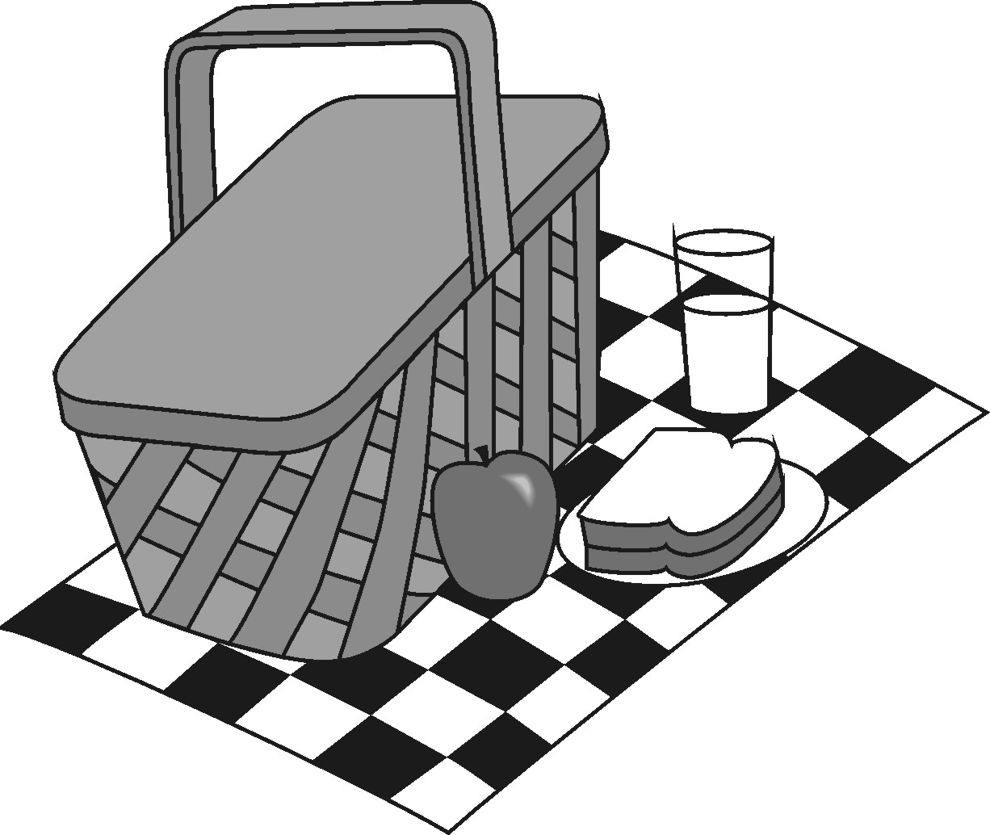

3. Feedback given liberally, like a signpost, to keep the child on the right track.

4. Consequences to help the child learn right from wrong, good from bad, the meaning of "no", and respect for one another.

5. Negotiation as a way out of conflicts when it is reasonable for both adult and child to be winners.

6. A clean and safe environment extending from one's home to the community and to the world.

7. Food, water, shelter, clothing, education and freedom from harm.

8. A chance to be special, a zillion times a year.

Directions

Take all the basic ingredients and blend them in equal and generous amounts (like chocolate chip cookies - more is better). Bake in a home warmed by caring and sharing. During the baking process, demonstrate all aspects of appropriate values. Treat each other well. Play with one another. Let your child participate in doing good deeds with you. Be prepared to stand back as the child rises. (You don't want to stifle rising children or they can fall flat. Also you don't want to open the door too quickly, before they are set to stand on their own. It's important to get it just right.)

If you follow this recipe as closely as you can, you will find that there is room for mistakes because when you use good ingredients the mix develops some forgiveness. (This is a secret ingredient that develops out of the combination effect of the other ingredients.)

When is it cooked?

The really neat thing about this recipe is that a child is always cooked, even when they continue to rise. You can enjoy your child anytime you take the time.

Bon Appetit!

