

Sexual Abuse Counselling
by Family Physicians

Gary Direnfeld, MSW, RSW

Sexual abuse reportedly affects one in four women and one in ten men.¹ The Canadian Incidence Study of Reported Child Abuse and Neglect (final report 2001) found that sexual abuse accounted for 10% of all child maltreatment investigations in 1998 with 38% of those found to be substantiated.² Further:

Touching and fondling genitals was the most common form of substantiated child sexual abuse, occurring in 68% of cases. Attempted and completed sexual activity accounted for over one-third (35%) of all substantiated reports. Adults exposing their genitals to children was reported in 12% of cases…

Sexual abuse is now linked to a number of personality, conduct, affective, eating, and substance abuse disorders.

However, sexual abuse as the underlying cause, frequently goes without notice.

Sexual abuse is now linked to a number of personality, conduct, affective, eating, and substance abuse disorders.^{3, 4, 5, 6} However, sexual abuse as underlying the aetiology of these various disorders and complaints continues to go unnoticed and untreated in many cases.

Freudian psychology and analysis brought forth possibly the greatest proliferation of thinking on the determinants of the human psyche and by extension, human behaviour. At the same time it obscured for almost three quarters of a century the fact that many women's hysteria or neuroses was founded in the reality of childhood sexual abuse as opposed to fantasy.

Freud had acknowledged real trauma, of course, but he put his emphasis on the child’s intrapsychic world of sexual desire and fantasized sexual experience, he did not develop a description of how real traumas can effect a child’s development. In the late 1920’s and early 1930’s, Freud’s colleague and friend in Budapest, Sandor Ferenczi, did develop very vivid and compelling portraits of the consequences of childhood sexual seduction and abuse, and formulated a rich theory of sexual traumatization. However, this work was marginalized in psychoanalysis and almost unknown in non-psychoanalytic psychology and psychiatry until the emphasis in CAN (child abuse and neglect) on sexual abuse brought it back into consideration.⁷

We are still coming to terms with the greatest obfuscation to a childhood reality that may have ever occurred. Only now are people regularly daring to ask the questions that make way for clear and detailed accounts of sexual abuse, yet many family physicians still do not screen for childhood trauma even though advocated in the literture.⁸ For the family physician, instruction on evaluating childhood sexual abuse is as recent as the 1990’s.^{9, 10, 11} Further:

Physicians are in a unique position to assist victims of sexual abuse during the healing process. Awareness of childhood sexual abuse and how to intervene when childhood sexual abuse is suspected, however, are not part of most physicians' basic training. Developing these skills may be one of the most valuable ways for a family physician to expand and improve the care he or she provides.⁶

More family physicians are venturing into the world of talk therapy and are able to utilize their unique knowledge of psychopharmacological intervention to assist the process of recovery. On the matter of counselling per se, a simple structure for detailing the counselling process may be of value.

To this end, this article provides such a structure as a simple heuristic to support those family physicians that endeavour to directly counsel adult survivors of childhood sexual abuse and help other physicians identify when to refer for specialized counselling.

Sexual Abuse Counselling has a Beginning, Middle and an End

Counselling with sexual abuse survivors can be conceptualized in three stages. Each stage has a series of core issues most of which are common in many counselling processes, but are particularly relevant for sexual abuse counselling. The following chart summarizes each stage and the core issues to be addressed. Each stage will be expanded upon in subsequent sections.
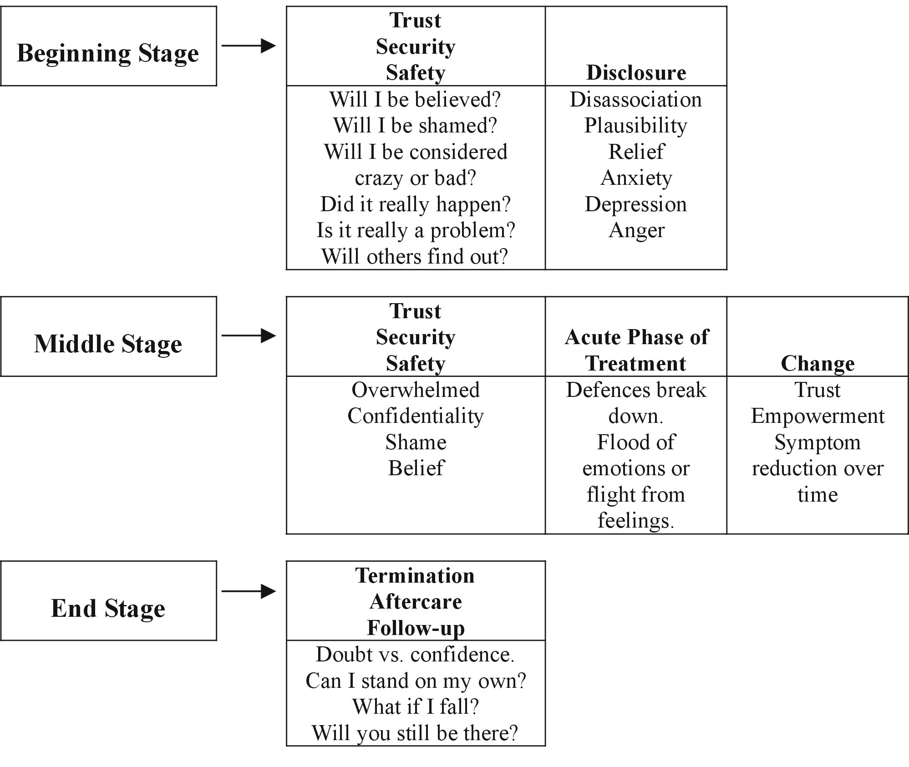

The Beginning Stage

Patients see a physician owing to some form of distress. If there weren’t distress, there would be no need for help. The distress may be expressed as physical, psychological, emotional, behavioural or psychiatric symptoms. The call for help occurs when symptoms exceed a tolerable threshold. To the patient yet to link their distress to issues arising from childhood sexual abuse, it may be the inquiry of the physician that provides the initial link and raises the issue of childhood sexual abuse. For other patients, they may be aware of their past abuse and are seeking help to address consequent distress. Either way, the beginning stage of counselling begins with disclosure of a past childhood trauma by the patient to the physician. This first stage of counselling may therefore be characterized by issues of trust, self-doubt, shame by the patient and fear of recrimination by the physician towards the patient if the patient views him or her as tainted given the abuse experience.

Advance preparation by the physician is necessary in order to manage the disclosure appropriately such that trust is developed with the patient. The trust is in the order of the patient being believed and not being judged negatively or as contributory to the abuse disclosed. Such physician preparation takes the form of prior reading on the topic and a basic understanding of the dynamics of sexual abuse, power imbalance and impact on child and adult functioning. The sense of trust as felt by the patient is crucial to their sense of safety and security with the physician. The issue of safety and security for the adult survivor is more psychological and emotional than physical per se, as the abuser is likely no longer in proximity to the survivor. However, this statement should not be taken as a fact, but as a hypothesis to be explored as a good many survivors do carry on relationships with their abuser, particularly when the survivor is yet to acknowledge the abuse or confront the abuser (should they choose to do so). It may be necessary right then and there for the physician to counsel the patient on issues of safety, if only psychological safety, in the event a relationship with the abuser continues.

In addition to advance preparation through reading and the like, the physician is advised to explore their own feelings and issues on the matter of childhood sexual abuse. This is to acquaint and acclimatize themselves with feelings that may arise in them when confronted by matters of childhood sexual abuse. In much the same way physicians may have to acclimatize to the surgical theatre during medical training, they may find a similar acclimatization process of value so as not to be overwhelmed by the intensity of their own feelings as well as their patient’s feelings which can be delivered with significant emotional intensity.

As a result of the disclosure, the patient may experience a flood of various emotions, which in turn may trigger a variety of defence mechanisms, up to, and including dissociative states. Further, the patient may experience vivid recollections of past abusive events. These recollections may inundate their consciousness during waking hours or intrude during sleep as nightmares. These are the hallmarks of Post Traumatic Stress Disorder (PTSD). The interventions of the physician include empathic listening, and reassurance to the patient that they are in a safe place whilst with the physician and that they are believed in their disclosure. Important in the first or initial stages of disclosure is actually limiting the disclosure so patients avoid overwhelming themselves. In future sessions as the patient comes to review their abuse history and acclimatize to the acknowledgement of their abuse, greater disclosure can proceed. By this time, the patient will have experienced the psychological safety the physician provides and can be more comfortable with greater disclosure sans the risk of being overwhelmed.
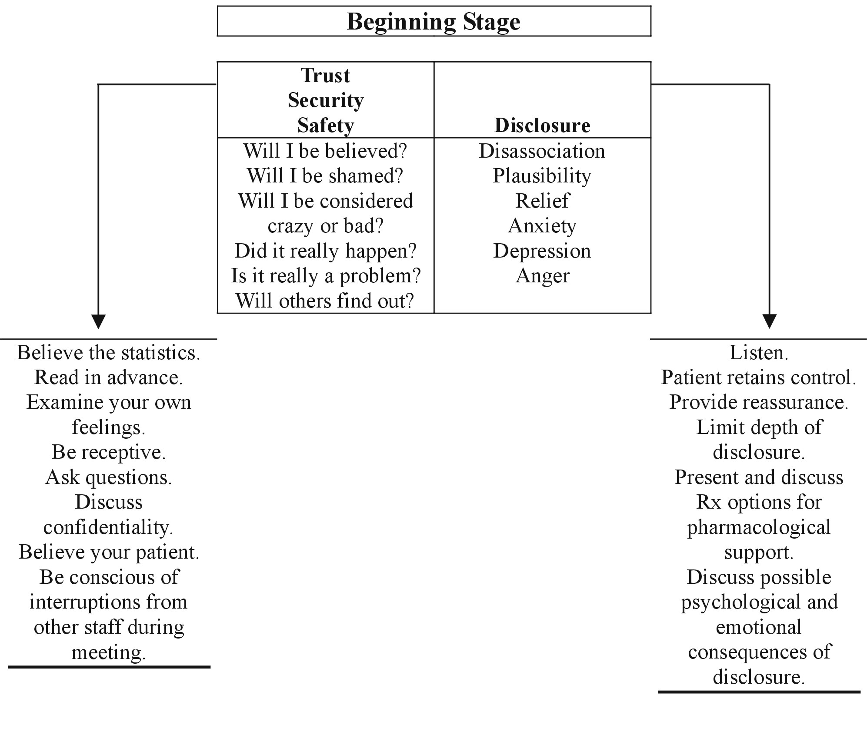

The beginning stage concludes with the physician educating the patient as to the counselling (treatment) process, the psychological and emotional sequelae of addressing one’s sexual abuse history and the supportive use of psychopharmacological interventions if necessary to alleviate anxiety or depression.

The Middle Stage

The middle stage of counselling begins as a continuation of the first. Issues of trust, safety and security are emergent and reoccurring themes. If there has been a prior unsuccessful counselling effort the patient may be ambivalent about the physician with concerns that the shortcomings of the previous experience will be experienced yet again. It is therefore important to survey prior counselling experiences with a view to determining present attitudes and concerns as matters for displacement upon the physician that can interfere with the counselling relationship.

Given different types of abuse, intra-familial and extra-familial, it is also important to identify the relationship of the abuser to the survivor and the context of the abuse as this will have additional bearing on trust, safety and security issues. With intra-familial sexual abuse the survivor often experiences issues of trust with intimate partners. With extra-familial sexual abuse, the survivor may have difficulty trusting either strangers or other persons in positions of authority. Some patients will have experienced both forms of abuse and hence their ability to trust under any circumstance may be fragile. In these cases, the development of trust with the treating physician may take longer to establish.

As the middle stage of counselling begins the patient’s sense of trust, safety and security can be facilitated by several interventions. At this time a limited course of anti-depressant medication, anxiolytics or sleep medication can bring symptomatic relief. (Even though patients are told that anti-depressant medication may take several weeks to reach therapeutic level, many are significantly comforted by the prescription alone.) Availability for crisis counselling, after hours availability and even permission to phone in the middle of the night can provide enough comfort to actually mitigate the use of the very service offered. This author routinely permits patients to phone 24 hours a day and informs the patient that a call for a five-minute conversation to reassure is preferred over their increasing distress which may result in breakdown and hospitalization with resultant additional issues to address and overcome. Given the reassurance such availability provides, patients rarely call and are reluctant to misuse this privilege. If a patient should call, there is likely good reason and significant distress. However, no patient of this author has ever had to be hospitalized in the event of a call. Rather, with reassurance, the patient either manages to await a morning crisis appointment or the matter resolves itself and the patient is next seen at their scheduled appointment.
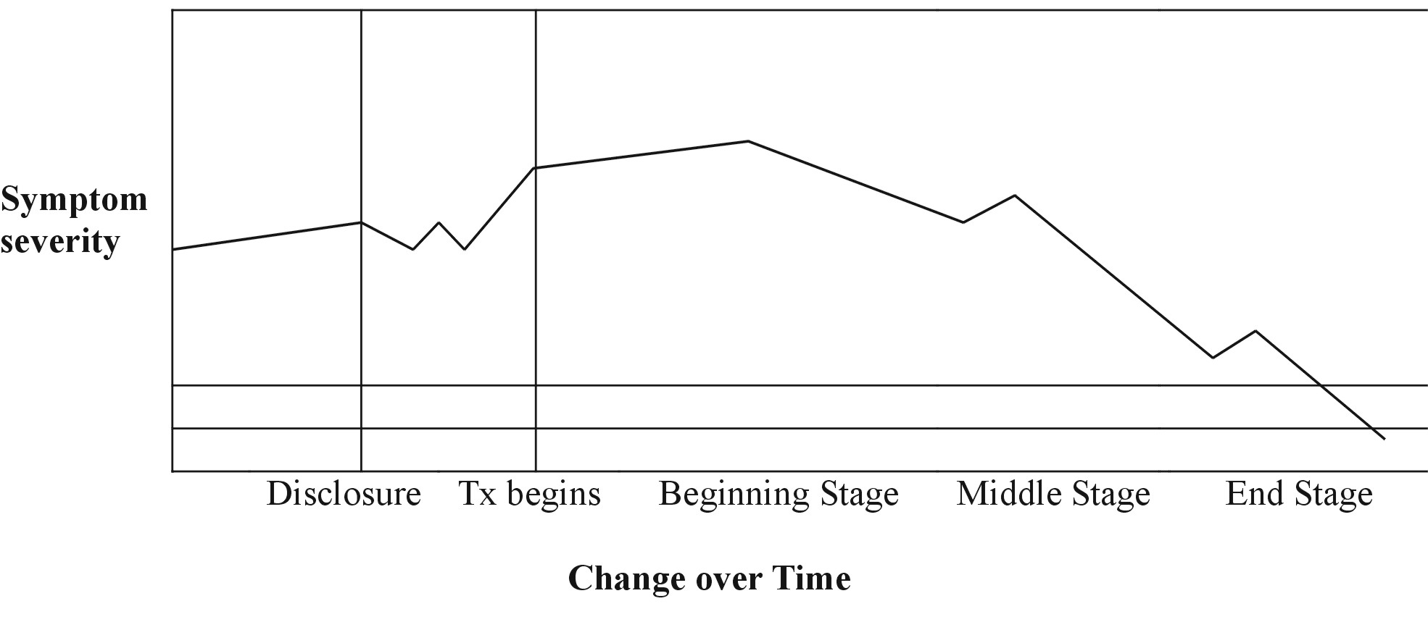
As counselling progresses, the patient’s defences will relax and more personal detail of the abusive events may be disclosed. While this is the time in counselling that some patients may further identify and explore the manifestations of abuse, the risk of the patient becoming overwhelmed remains. The role of the physician is to normalize these reactions and help the patient pace their disclosure and exploration of events and thus facilitate them gaining control of their own emotions and reactions. Throughout, the physician helps the patient make connections from past abusive events to present day symptoms.
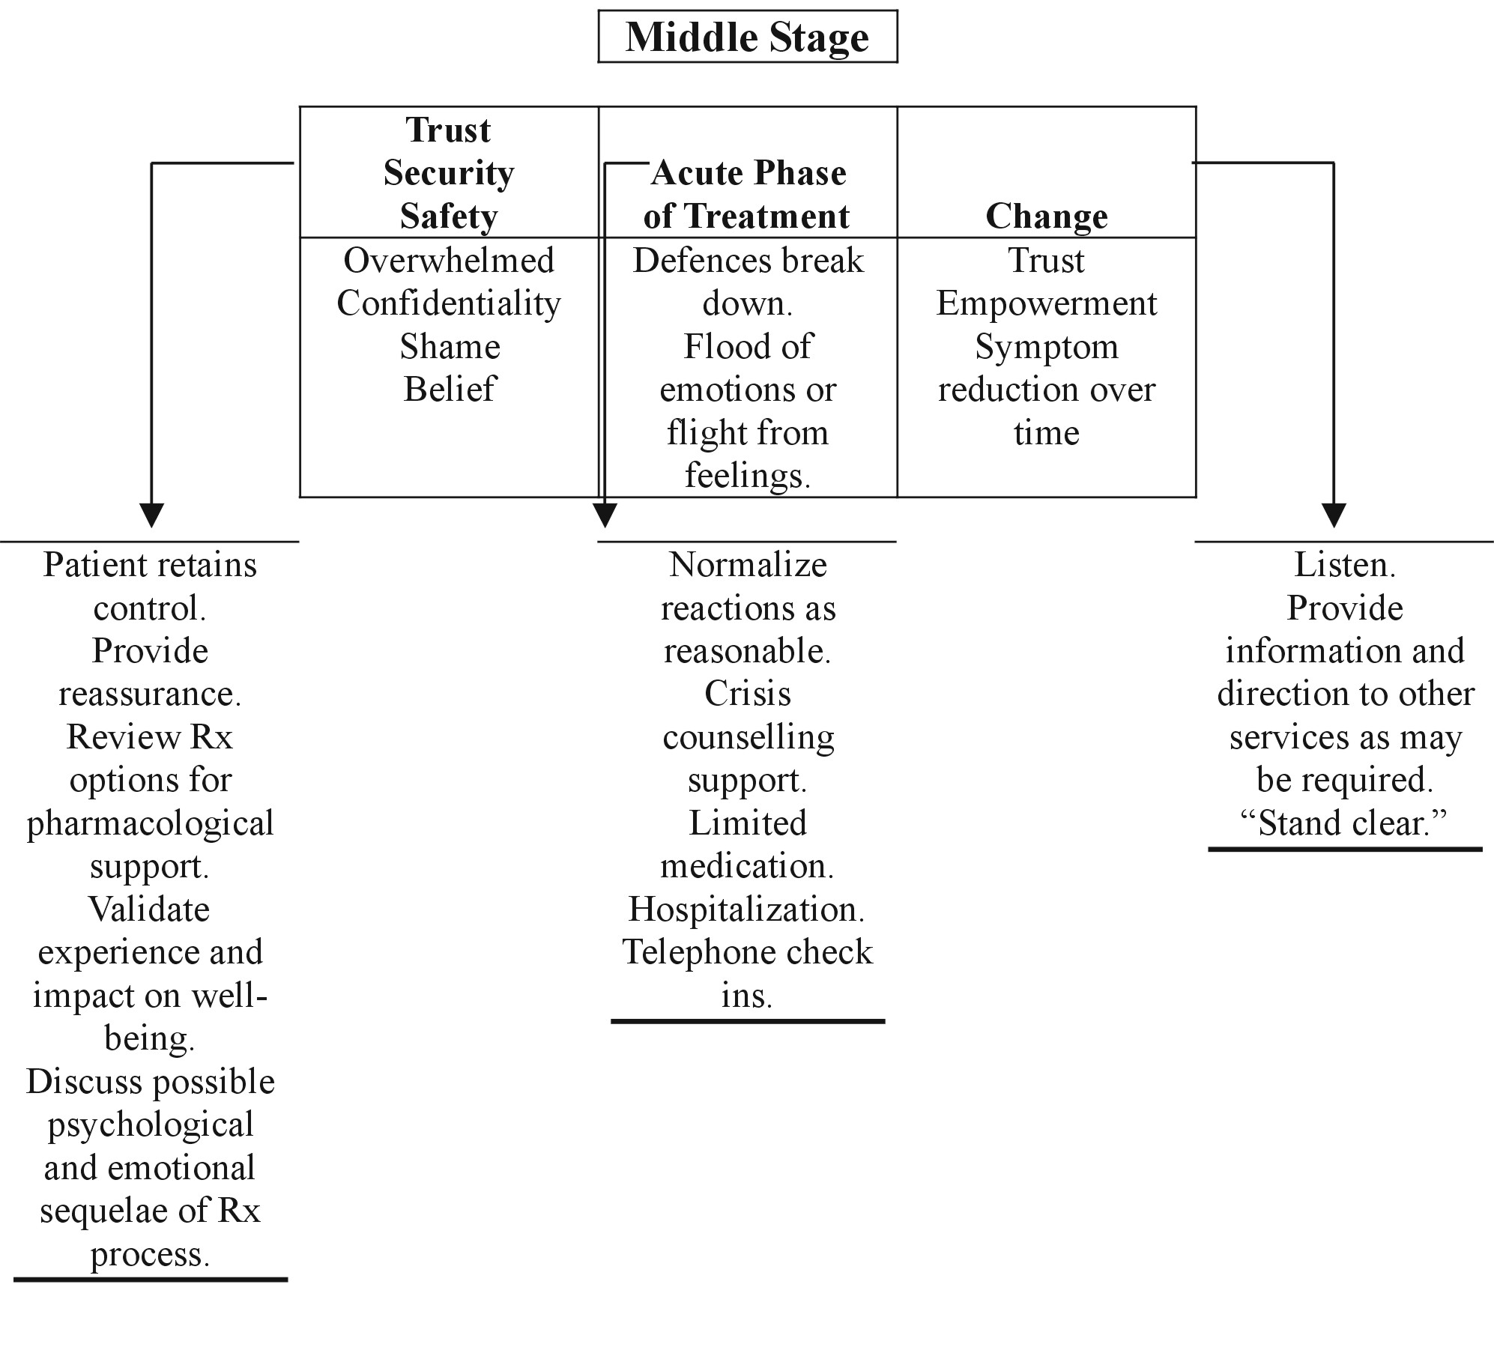

In the middle stage of counselling the patient may experience relief and/or exacerbation of symptoms. This is to be expected as they come to address issues of distress. The physician can draw a simple graph as shown above to illustrate the likely ups and downs the patient may experience over the course of counselling. By demonstrating and predicting these fluctuations, they are then normalized and no longer viewed as evidence of deterioration by the patient, but rather are reframed as evidence that the patient is moving through the recovery process.

In helping the patient to gain control of their emotions and reactions and in helping to make connections between past abusive events and current symptoms, the patient gains understanding of their situation and problems therein. They learn that the abuse and current symptoms are not a function of their worth, value and humanity, but wrongful events perpetrated against them beyond their control with devastating effects owing to the dynamics of the situation. Through the counselling process the survivor learns to separate their sense of self from the abuse and the abuser and learns to establish an independent identity through which they may now make conscious choices. They are then in a position to learn cognitive and/or behavioural strategies for managing symptoms and they can more appropriately assess their own interpersonal relationships and make choices therein. They are better able to identify and separate their needs and issues from others, and where appropriate, place their needs ahead of others or alternately as in the case of parenting, put their children’s needs ahead of their own.

Over time and as the middle stage of counselling continues, symptom reduction is expected. The course of the reduction can take several forms including reductions of intensity, duration and frequency. It may be important to discuss with the patient these various indicators of symptom reduction. Some patients who experience intrusive and vivid recollections of past abusive events may experience them with the same intensity, yet either their duration or frequency may diminish. Alternately, intensity may diminish but duration and frequency may remain the same. It is therefore important to review symptoms along these three dimensions so as to provide tangible evidence to the patient that symptoms are improving. In time symptom reduction in all dimensions is expected and preferred, but the patient must be informed that change may not occur in all manner equally, nor in a linear progression. As patients gain insight and develop their cognitive and behavioural repertoire to mange themselves, the role of the physician changes from active intervener to observer/witness and at times cheerleader. The physician now plays a powerful role in reinforcing the changes through significant positive feedback based upon tangible symptom reduction and improved psychosocial functioning. Nonetheless, even improvement carries risks. As a result of counselling, some patients will move from depression to anger at the perpetrator and may then require information and support as they consider a range of responses. The responses can include; discussion with other family members, friends or community members; confrontation with the abuser; and even making a criminal report to police with the intent of seeing criminal charges laid. Some patients, having explored their family system and the role of the abuser, may move on to explore the role of other family members whose silence may now cause them to be viewed as co-conspirators or enablers through acts of commission or omission. Furthermore and as a result of counselling, the patient’s current interpersonal relationships can be destabilized. Couple or family counselling may be indicated to facilitate systemic adjustments. These interventions can occur concurrent to the patient’s individual counselling (parallel process) or after individual counselling has been terminated (serial process).
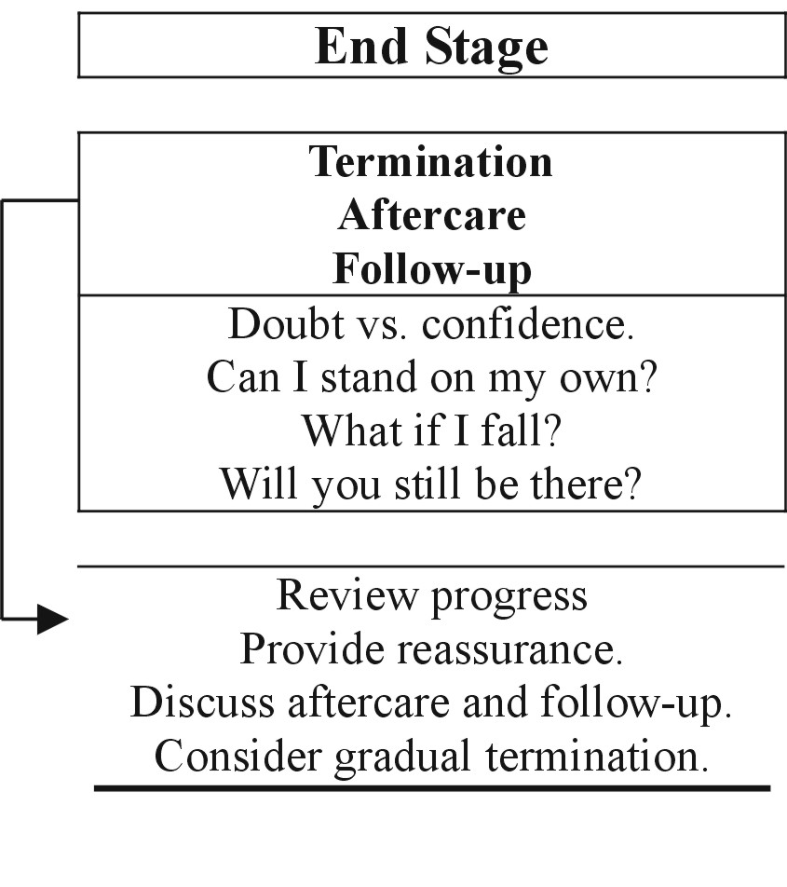

The middle stage draws to a close as the patient demonstrates enough symptom relief and improved psychosocial functioning to manage independently. The issue as they enter the end stage of counselling is fear of letting go of physician support, relapse and reconnecting with established or new social systems.

The End Stage

As with any successful counselling process, the patient tends to feel gratitude and a reluctance to let go. However, in the case of sexual abuse counselling, these feeling may be intensified. It is common for sexual abuse survivors to have had very fractured separations from their family of origin, particularly in the case of intra-familial sexual abuse. Their relationship to the physician-counsellor may have been their healthiest inter-personal experience in that it was non-exploitive. This can give rise to a significant attachment of the survivor to the physician. It is important then for the physician to reaffirm their role as helper and although caring, not an ongoing figure in the survivor’s life. In much the same way as Dante had Beatrice and Dorothy had a tin man, cowardly lion and scarecrow, the physician is but a passing helper in the life of the patient. These and other similar stories may help the patient come to terms with the end of counselling and the role of physician as counsellor.

The patient will naturally struggle, vacillating between confidence and doubt. Historically their self-management has been tenuous; otherwise they would not have sought outside relief from distress in the first place. It will take time for them to learn to rely on their improved psychosocial functioning and new skill sets. The patient may demonstrate a rapprochement with the physician understanding the need to separate and terminate yet requiring a sense of closeness and availability at the same time. All these matters are grist for discussion and problem solving in the end stage of counselling.

Interventions include reviewing progress, providing reassurance and at times offering a graduated termination process. A graduated termination process generally sets out a series of successive appointments with greater duration between appointments over time and for lesser duration per appointment. Some patients can be reassured by knowing they may reconnect if they feel the need. For some this is conceptualized as a “booster shot”.

For some patients the end of the physician counselling may be the beginning of other services such as ongoing support groups or educational opportunities. In all cases, the survivor is encouraged to go out into life, manage ambiguity and uncertainty, learn and flourish.

Discussion

The counselling process described above is provided as a heuristic to enable family physicians to better manage their treatment of adult survivors of childhood sexual abuse. In the context of this author’s private counselling practice and during an extensive history taking, all clients are routinely asked if they have ever been touched in a way that has made them feel uncomfortable. The question as posed, opens the door to every imaginable form of touching. If the client truly has not had an unwanted touch of any type in any manner, they quickly say no. However, if the client has had an unwanted touch, they may disclose it quickly, or divert from eye contact so as to avoid the question, but thus already giving indication of an issue that may bear further exploration. Some answer the question with a question, seeking clarification, “do you mean sexual, or physical.” Again however, the client thus provides clues of unwanted touching experiences. At times though, even when asked, some clients are so psychologically removed from the abusive events that it fully escapes their awareness, only to surface later.

The case examples below come from this author’s private practice. Names and identifying data have been altered to protect the identity of patients and other people.

Sexual abuse counselling is a vital intervention as the issue is contributory to so many forms of adult personal and interpersonal dysfunction. It is this author’s hope, by way of this article, that those physicians who practice counselling may be better equipped to help and those who do not practice counselling will be better informed as to thus make appropriate referrals for treatment.

References
- Faller, Kathleen Coulborn, Child Sexual Abuse: Intervention and Treatment Issues, User Manual Series, U.S. Department of Health and Human Services, Administration on Children, Youth and Families, National Center on Child Abuse and Neglect, 1993
- Trocmé, Nico, et al, Canadian Incidence Study of Reported Child Abuse and Neglect: Final Report, National Clearinghouse on Family Violence, Health Canada, 2001

Windle M, Windle RC, Scheidt DM and Miller GB, Physical and sexual abuse and associated mental disorders among alcoholic inpatients, American Journal of Psychiatry, American Psychiatric Association, 1995; 152:1322-1328
- Whealin, Julia, Child Sexual Abuse, A National Center for PTSD Fact Sheet, at www.ncptsd.org/facts/specific/fs_child_sexual_abuse.html, accessed October 27, 2004
- Polusny MA, Follette VM, Long-term correlates of child sexual abuse: Theory and review of empirical literature. Applied and Preventive Psychology 4:143–66. (1995).
- Hendricks-Matthews, Marybeth, Caring for victims of childhood sexual abuse – Editorial, Journal of Family Practice, Nov, 1992
- Young-Bruehl, Elisabeth, Discovering Child Abuse, Section V of the Division of Psychoanalysis of the American Psychological Association, at www.sectionfive.org/essay_young_breuhl2.htm, accessed October 27, 2004
- Seng JS, Petersen BA, Incorporating routine screening for history of childhood sexual abuse into well-woman and maternity care, Journal of Nurse Midwifery, 1995 Jan-Feb;40(1):26-30
- Bala M, Caring for adult survivors of child sexual abuse. Issues for family physicians, Comment in Canadian Family Physician, 1994 Sep;40:1509
- Vincent, E. Chris, Gibbons Mary, What you need to know about childhood sexual abuse – Editorial, American Family Physician, Feb 1, 1995
- Guidry, Harlan Mark, Childhood sexual abuse: Role of the family physician, American Family Physician, Feb 1, 1995
- Dybicz, Phillip, An Inquiry Into Practice Wisdom, Families in Society: The Journal of Contemporary Social Services, Alliance for Children and Families, 2004, 197-203

Gary Direnfeld, MSW, RSW
(905) 628-4847
gary@yoursocialworker.com
http://www.yoursocialworker.com
Gary Direnfeld is a social worker. Courts in Ontario, Canada, consider him an expert on child development, parent-child relations, marital and family therapy, custody and access recommendations, social work and an expert for the purpose of giving a critique on a Section 112 (social work) report. Call him for your next conference and for expert opinion on family matters. Services include counselling, mediation, assessment, assessment critiques and workshops.

